Map Types Notes
Political Maps-

Physical Maps-

Two types of physical maps and definitions:
1.

2.

Climate Maps-

Land Use Resource Maps-

Contour Maps-

Topographic Maps-

Name____________________
Class and Period_____________________
Map Elements and Types
Part 1- Write the name of each map element below the picture.
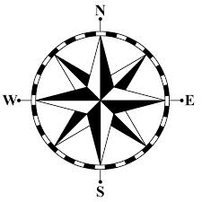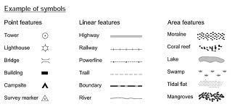
1._____________________ 2._______________________
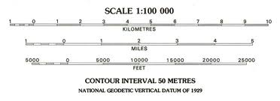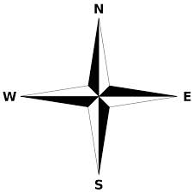
3._______________________ 4._________________________
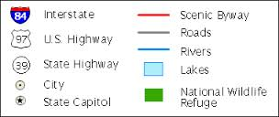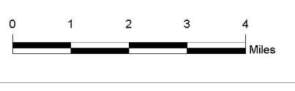

5.________________________ 6.__________________________

Part 2- Fill in the blank with the correct map type:
- This type of map uses colors to show height above sea level. ____________________________
- These colorful maps show lines that people use to divide countries and states. They also show major cities. _____________________________
- These maps show features on the Earth like rivers, mountains, and deserts. ____________________________
- These maps show how land is being used. For example, they might show which crops are being grown or what animals are being raised. __________________________
- These maps show climate regions. ___________________
- These maps show what you would see from space.________________
- If you were hiking in the mountains you would want to have this type of map with you. _____________________________
- If you were looking for a natural feature, you would want to have this type of map. _____________________________
- If you were trying to find out what resources were in an area, you would want this type of map._________________________
- You want to take a vacation in a place with the perfect weather. What type of map would you use?________________________
- If you are looking for the lowest point in an area, what type of map would you need? _______________________________
- What map element tells us how far features are from one another?________________________________

Part 3- Map skills check:
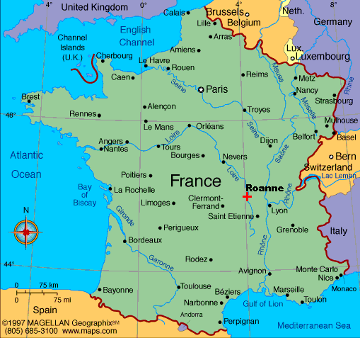
- What type of map is this?

- What is this a map of?

- Fill in the rest of the directions in the compass rose.
- Put a circle around the scale.

- What is this map missing that would tell us what things mean on the map?

- Approximately how many miles is it from Paris to Orléans?
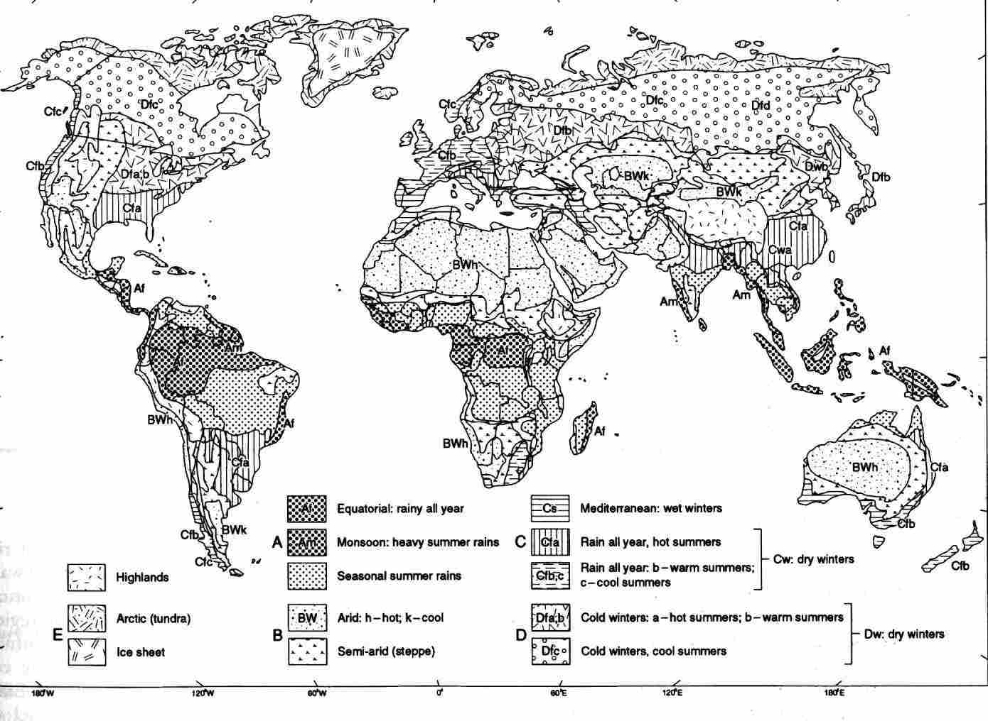

- What type of map is this?______________________________________________
- Describe the climate in New Orleans.__________________________________
- Describe the climate in the center of Australia._________________________
- Describe the climate in Africa near the equator.________________________
- Which two general locations have climate type Dfc?___________________
- What does the abbreviation BWk mean?_______________________________
- What does the abbreviation Cfa mean?________________________________
- Where can you find the Ice Sheet?_____________________________________

