Major Belief Systems of the World- Monotheistic
Name | Name of founder, Date and Place | Major Beliefs and Worship | Leaders and Sacred Text | Holidays
Judaism

Christianity

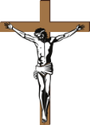
Islam

Major Belief Systems of the World- Polytheistic or Non-Theistic
Name | Name of founder, date and place | Major Beliefs and Practices | Leaders and Sacred Text | Holidays or Practices
Hinduism

Buddhism

Confucianism

